Project Performance Testing
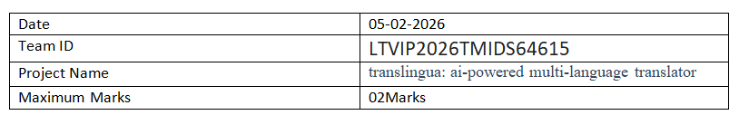
Project testing at TransLingua (NYC/Boulder) is a comprehensive, multi-stage quality assurance process aimed at ensuring that translated, localized content is accurate, culturally appropriate, and functional within its final format. Their methodology involves a, rigorous review process where professional, native-speaking linguists, rather than just automated tools, verify the quality of the translation.
Key Aspects of Project Testing at TransLingua:
- Pre-Translation Review: Before the main project begins, TransLingua conducts a review to identify potential issues, such as phrases that do not translate well or cultural nuances that may require adaptation, reducing errors early in the process.
- Contextual Accuracy and Cultural Sensitivity: Testing goes beyond mere proofreading to ensure that the content resonates with the target audience and is culturally appropriate, avoiding issues with idioms or local colloquialisms.
- Consistency and Technical Precision: Using Translation Memory (TM) systems, they ensure consistent terminology across large projects. This includes checking technical, legal, and specialized industry terms (e.g., medical devices, engineering).
- Types of Testing:
  - Linguistic Quality Assurance (LQA): Reviewing for grammar, style, and accuracy.
  - Formatting and Layout (DTP): Ensuring that the translated text fits correctly in the layout, especially when character counts differ (e.g., German text often being longer than English).
  - Functional Testing: For websites and apps, they test that language switchers work, URLs are localized, and the site functions correctly in all supported languages.
- Specialized Services: TransLingua offers specialized testing for advertising and marketing (transcreation), where they test creative concepts and brand names for local impact.

